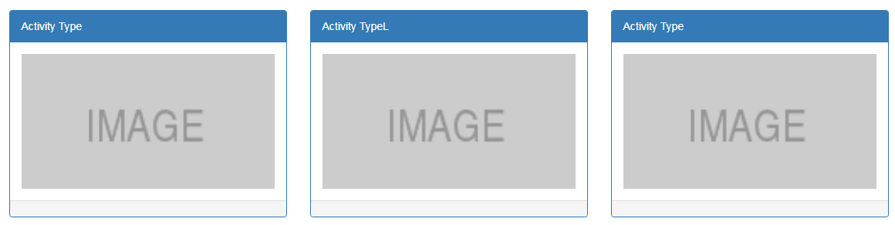

Page 1

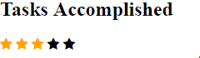

Page 2



Take a bike ride

around town



Page 3

Build with:

React,

Node

Mongo,

Main components:

1) Nav bar

-User name (property), link (component)

-Tracker

-Resources

2) Score/Task

3) Game Tile

-Activity Tile component

-Props of activity tile (image and text)

-Response component (Accept, Decline)

Questions:

1) What to use for sign in? oauth

2) How to procure and apply data for Tracker?

Definition for tracker is based on activity chosen.

For mongo data store:

Id#, date completed, user, activity